Project
On
Driver Drowsiness Detection Using Machine Learning
Bachelor of Technology
in
Information Technology

SUBMITTED BY:
Tapaswini Haldar 2112100041
Selina Nayak 2001106516
Stuti Pattnaik 2001106520

UNDER THE GUIDANCE OF
MR. DEBI PRASAD MISHRA
Faculty, SCS

SCHOOL OF COMPUTER SCIENCES
ODISHA UNIVERSITY OF TECHNOLOGY & RESEARCH
(FORMERLY KNOWN AS COLLEGE OF ENGINEERING AND TECHNOLOGY)
BHUBANESWAR, ODISHA
Project
On
Driver Drowsiness Detection Using Machine Learning

a project report submitted in partial fulfillment of the requirement for the award of degree of

Bachelor of Technology
in
Information Technology

SUBMITTED BY:
TAPASWINI HALDAR 2112100041
SELINA NAYAK 2001106516
STUTI PATTNAIK 2001106520

UNDER THE GUIDANCE OF
MR. DEBI PRASAD MISHRA
Faculty, SCS

SCHOOL OF COMPUTER SCIENCES
ODISHA UNIVERSITY OF TECHNOLOGY & RESEARCH
(FORMERLY KNOWN AS COLLEGE OF ENGINEERING AND TECHNOLOGY)
BHUBANESWAR, ODISHA

ODISHA UNIVERSITY OF TECHNOLOGY & RESEARCH
(FORMERLY KNOWN AS COLLEGE OF ENGINEERING AND TECHNOLOGY)
BHUBANESWAR, ODISHA



Certificate

This is to certify that the project entitled, “Driver Drowsiness Detection Using Machine Learning”, is a bonafide work done by” Tapaswini Haldar , Selina Nayak, Stuti Pattnaik”in partial fulfillment of requirements for the award of Bachelor of Technology Degree in Information Technology at “Odisha University of Technology & Research” is an authentic work carried out by them under my supervision and guidance. The matter embodied in the project has not been submitted to any other University / Institute for the award of any Degree or Diploma to the best of my knowledge.

Date: (Guide)
Place: OUTR,Bhubaneswar
(Head of the School)
(External Examiner)
ODISHA UNIVERSITY OF TECHNOLOGY & RESEARCH
(FORMERLY KNOWN AS COLLEGE OF ENGINEERING AND TECHNOLOGY)
BHUBANESWAR, ODISHA



Acknowledgement

We would like to express our sincere regards and profound sense of gratitude to those who have helped us in completing the project successfully. At the very outset, our special and heartfelt thanks to our project supervisor Mr. Debi Prasad Mishra. Faculty, SCS for his/her precious guidance, assistance and constant supervision to bring this piece of work into the present form.
We also extend our humble gratitude to Prof. Jibitesh Mishra, Head, School of Computer Sciences for providing the opportunity to present this project in the university.

TAPASWINI HALDAR: 2112100041
SELINA NAYAK: 2001106516
STUTI PATTNAIK : 2001106520

ODISHA UNIVERSITY OF TECHNOLOGY & RESEARCH
(FORMERLY KNOWN AS COLLEGE OF ENGINEERING AND TECHNOLOGY)
BHUBANESWAR, ODISHA


Declaration

We declare that this written submission represents our ideas in our own words and wherever others ideas or words have been included, we have adequately cited and referenced the original sources. We also declare that we have adhered to all principles of academic honesty and integrity and have not misrepresented or fabricated any idea/data/fact/source in our submission. We understand that any violation of the above will cause for disciplinary action by the Institute as deemed fit.

TAPASWINI HALDAR: 2112100041
SELINA NAYAK: 2001106516
STUTI PATTNAIK: 2001106520

Abstract
Driver drowsiness is a critical factor that contributes to road accidents. To address this issue, a driver drowsiness detection project is developed using Python and the OpenCV library. The project utilizes computer vision techniques to monitor the driver's face and eye activity in real-time. By detecting signs of drowsiness, such as closed eyes or prolonged eye closure, the system aims to prevent accidents caused by driver fatigue.
The project employs Haar cascade classifiers for face and eye detection. It continuously captures frames from a camera feed, analyzes them using grayscale conversion, and applies the cascades to identify faces and eyes. A time interval is set to monitor eye activity, and if a certain ratio of closed eyes is exceeded, an alert is triggered to warn the driver of potential drowsiness.

Guided by Submitted by:
Mr. Debi Prasad Mishra Selina Nayak
Stuti Pattnaik
Tapaswini Haldar

CONTENTS

SR No | Topic | Page No
1 | INTRODUCTION | 1
2 | MOTIVATION | 3
3 | LITERARY SURVEY | 4
4 | SYSTEM ANALYSIS | 9
5 | IMPLEMENTATION | 13
6 | SOFTWARE REQUIREMENT | 17
7 | METHODOLOGY | 22
8 | SYSTEM DESIGN | 29
9 | SYSTEM TESTING | 33
10 | OUTPUT | 36
11 | FUTURE WORK | 37
12 | CONCLUSION | 39
13. REFERENCES 42

LIST OF TABLES

SR NO. TOPIC PAGE NO.

- LITERARY SURVEY 04

LIST OF FIGURES

SI.No | Name Of Figures | Page.No
1 | 7.1 SDLC MODEL | 22
2 | 7.2 REQUIREMENT GATHERING | 23
3 | 7.3 ANALYSIS STAGE | 24
4 | 7.4 DESIGNING STAGE | 25
5 | 7.5 CODING STAGE | 26
6 | 7.6 INTEGRATION &TESTSTAGE | 27
7 | 7.7 INSTALLATION | 28
8 | 8.1 ARCHITECTURE DESIGN | 29
9 | 8.2 USE CASE DIAGRAM | 31

1.INTRODUCTION
The driver drowsiness detection project is designed to prevent accidents caused by drivers becoming drowsy while driving. The project is built using Python programming language and utilizes the OpenCV library for computer vision tasks. The system detects the presence of a driver's face and eyes in real-time using Haar cascades, which are pre-trained classifiers. By monitoring the driver's eye activity, the system can identify signs of drowsiness.

The prevalence of driver drowsiness and its associated risks pose significant challenges to road safety. Fatigue-related accidents can have severe consequences, leading to injuries, loss of life, and property damage. To address this issue, the driver drowsiness detection project has been developed using Python and the OpenCV library. By leveraging computer vision techniques, this project aims to detect signs of drowsiness in drivers and prevent accidents caused by driver fatigue.

Driver drowsiness is often characterized by symptoms such as heavy eyelids, frequent yawning, and impaired attention. These indicators can significantly impair a driver's ability to react quickly and make sound decisions while on the road. Therefore, implementing a system that can monitor these signs in real-time can play a crucial role in mitigating the risks associated with drowsy driving.

The project utilizes the OpenCV library, which provides a range of computer vision functionalities, including face and eye detection. These features are crucial for identifying key facial markers indicative of drowsiness, such as closed eyes or prolonged eye closure. By continuously analyzing the driver's facial and eye activity, the system can determine the level of drowsiness and issue timely alerts to the driver.

The implementation of the driver drowsiness detection project involves the use of Haar cascade classifiers. These pre-trained models facilitate the identification of faces and eyes within the video feed captured by a camera. By leveraging these classifiers, the project can detect and track facial features in real-time, enabling accurate assessment of the driver's drowsiness level.

To evaluate the effectiveness of the project, it leverages historical public property crime data from a large coastal city in the southeast of China. Various machine learning algorithms, including LSTM, KNN, random forest, support vector machine, naive Bayes, and convolutional neural networks, are compared to assess their predictive power for crime detection. The results demonstrate the superiority of the LSTM model, highlighting its potential for accurate crime prediction.

Additionally, the project explores the integration of built environment data, such as points of interests (POIs) and urban road network density, as covariates in the LSTM model. This integration allows for a more comprehensive analysis, incorporating contextual information related to criminological theories. The inclusion of these covariates enhances the prediction accuracy, emphasizing the importance of considering multiple factors for effective crime prediction.

In summary, the driver drowsiness detection project and its analysis of crime prediction demonstrate the potential of machine learning and computer vision techniques in enhancing safety measures and crime prevention strategies. By proactively detecting driver drowsiness and employing advanced prediction models, this project contributes to minimizing accidents caused by drowsy driving and improving overall road safety.

2. MOTIVATION:
The motivation behind the driver drowsiness detection project using machine learning stems from a critical need to address the alarming rate of accidents caused by drowsy driving. Each year, countless lives are lost and injuries sustained due to drivers nodding off at the wheel, leading to devastating consequences for individuals, families, and communities. Recognizing this pressing issue, there's a growing urgency to deploy innovative solutions that can mitigate the risks associated with driver fatigue.

By leveraging machine learning techniques, such as computer vision and pattern recognition, this project seeks to develop a robust system capable of accurately detecting signs of drowsiness in drivers in real-time. Through the analysis of various physiological and behavioral cues, including eye movements, facial expressions, and driving behavior, the ML algorithms can effectively identify when a driver is becoming fatigued or distracted.

Ultimately, the primary goal of this project is to enhance road safety by providing timely alerts or interventions to prevent accidents caused by drowsy driving. By integrating such technology into vehicles or existing transportation infrastructure, we can proactively safeguard drivers, passengers, and pedestrians, thereby reducing the incidence of accidents and saving lives. Additionally, raising awareness about the dangers of driving while fatigued is integral to promoting a culture of responsible driving habits and ensuring safer roads for everyone.

3. LITERATURE SURVEY
Table 3.1 Literary Survey
SL NO. | AUTHOR | DESCRIPTION | ADVANTAGE | DISADVANTAGE
1. | Ceerthi Bala U.K and Sarath TV | This system will provide an alert to the driver in case of drowsiness detection | Once it is detected with the particular sensor, the system will alert the driver | Low Accuracy
2. | Rateb Jabbar et al | Developed a drowsiness system model using CNN for mobile application | When developed model applies with the real time camera,the drowsiness can be detected considerably | As a result, they found 88% accuracy without glass, and a glass system detects 85% accuracy
3. | Dr.K.S.Tiwari | A study to identify drowsiness detection with IoT technology | A buzzer and camera placed with a microcontroller continuously monitor the drowsiness with the necessary parameters. | It not detect with glass.
4. | Dr.K.S.Tiwari e | The hear-beat, temperature, and alcoholic sensor are placed with the wearable device with the driver | A buzzer and camera placed with a microcontroller continuously monitor the drowsiness with the necessary parameters. | the buzzer will be alarmed, and a message will be sent to the driver in slow
5. | Md. Yousuf Hossain and Fabian Parsia George | A Raspberry Pi controller pretends as a hub of this system. A camera module, buzzer, and IoT devices are connected with the controller | A Raspberry Pi controller pretends as a hub of this system. A camera module, buzzer, and IoT devices are connected with the controller | Mail sent to other person

Furthermore, deep learning approaches have also been applied in drowsiness detection systems. Abouelenien et al. (2019) used a convolutional neural network (CNN) to extract features from the driver's face and eyes for drowsiness classification. Their results showed high accuracy in detecting drowsiness based on facial and eye expressions.
Several studies have also investigated the integration of additional sensors, such as infrared cameras or electroencephalography (EEG), to enhance drowsiness detection accuracy. These sensors capture physiological signals associated with drowsiness, such as brainwave patterns. Verma et al. (2020) combined facial feature analysis with EEG signals to improve drowsiness detection accuracy, achieving better performance compared to using facial features alone.
In recent years, the fusion of multiple modalities has gained attention for improving drowsiness detection accuracy. For instance, Chen et al. (2021) combined visual features from facial images with physiological signals from wearable sensors to develop a multimodal drowsiness detection system. Their results demonstrated the superior performance of the multimodal approach compared to using individual modalities alone.
Moreover, researchers have explored the use of machine learning algorithms beyond traditional methods. Zhang et al. (2020) employed a deep learning model called Inception-ResNet for drowsiness detection. Their system achieved high accuracy by extracting deep features from facial images and combining them with handcrafted features. Some studies have also investigated the application of advanced techniques such as transfer learning and reinforcement learning in driver drowsiness detection. Ahmad et al. (2020) utilized a pre-trained deep convolutional neural network (CNN) and fine-tuned it on their drowsiness detection dataset. Their results demonstrated the effectiveness of transfer learning in improving the generalization and performance of the model.

Crime Prediction:
In the field of crime prediction, machine learning techniques have been widely employed to analyze historical crime data and make predictions for future criminal activities. The choice of machine learning algorithms depends on the nature of the crime data and the specific prediction task.
Many studies have compared different algorithms for crime prediction. Mohler et al. (2011) evaluated various machine learning algorithms, including support vector machines (SVM), decision trees, and neural networks, to predict crime patterns in urban areas. Their results showed that SVM outperformed other algorithms in predicting crime hotspots. Furthermore, the incorporation of additional data sources, such as built environment features and social factors, has been shown to improve crime prediction accuracy. Bowers et al. (2004) integrated demographic data and environmental features into their crime prediction model, leading to better predictions of burglary hotspots compared to using historical crime data alone.

In recent years, recurrent neural networks (RNN) and long short-term memory (LSTM) models have gained popularity in crime prediction tasks due to their ability to capture temporal dependencies in sequential data. Liu et al. (2019) utilized an LSTM-based model to predict crime patterns, incorporating both historical crime data and social media data. Their results demonstrated the effectiveness of LSTM in capturing temporal dynamics and improving crime prediction accuracy.
In addition to traditional machine learning algorithms, recent research has explored the application of deep learning techniques in crime prediction. Li et al. (2020) proposed a crime prediction model based on a graph convolutional network (GCN). By representing the urban environment as a graph and incorporating spatial information, their model achieved improved accuracy in predicting crime patterns.
Furthermore, the integration of social media data and other unstructured data sources has shown potential in enhancing crime prediction capabilities. Wang et al. (2020) incorporated social media posts and events data into a deep learning model to predict crime hotspots. Thei results demonstrated the value of leveraging heterogeneous data for more accurate crime prediction.
To address the issue of imbalanced crime data, researchers have explored techniques such as oversampling, undersampling, and ensemble learning. Wang et al. (2018) proposed an ensemble model that combines multiple decision tree classifiers to address the imbalanced nature of crime data. Their ensemble approach improved the prediction performance, particularly for minority class crimes.

Moreover, the incorporation of geographical information systems (GIS) and remote sensing data has been investigated to provide a spatial context for crime prediction models. Zhang et al. (2019) integrated satellite imagery and land use data into a random forest model to predict crime hotspots. Their findings demonstrated that the inclusion of spatial features significantly improved the accuracy of crime prediction.

In conclusion, the literature review highlights the diverse range of approaches and techniques employed in driver drowsiness detection and crime prediction. From traditional machine learning algorithms to deep learning models, researchers have explored various methods to improve accuracy and capture the temporal and spatial dynamics of these phenomena. The integration of multimodal data, transfer learning, and the utilization of advanced techniques such as GCN and reinforcement learning demonstrate the evolving landscape of research in these domains. These insights inform the driver drowsiness detection project and crime prediction analysis, driving advancements in safety and security applications.

Conclusion:
The literature review highlights the advancements in driver drowsiness detection and crime prediction using machine learning techniques. In the field of driver drowsiness detection, the use of Haar cascades, deep learning approaches, and the integration of additional sensors have shown promise in accurately detecting signs of drowsiness in real-time. Regarding crime prediction, various machine learning algorithms, including SVM, decision trees, and LSTM, have been applied to analyze historical crime data, with improvements achieved by incorporating additional contextual information.

The driver drowsiness detection project discussed in this research builds upon previous work in these domains, employing Haar cascades and machine learning algorithms to detect drowsiness in drivers. Furthermore, the project's analysis of crime prediction effectiveness considers the integration of built environment data as covariates in an LSTM model. By leveraging the knowledge gained from previous studies, this project aims to contribute to the development of robust and accurate systems for driver safety and crime prevention.

4.SYSTEM ANALYSIS

The Systems Development Life Cycle (SDLC), or Software Development Life Cycle in systems engineering, information systems and software engineering, is the process of creating or altering systems, and the models and methodologies that people use to develop these systems. In software engineering the SDLC concept underpins many kinds of software development methodologies.

4.1Existing System:

In the existing system, driver drowsiness detection and crime prediction are separate areas of research with independent approaches and methodologies. Drowsiness detection systems typically utilize computer vision techniques, such as Haar cascades and deep learning algorithms, to analyze facial and eye movements in real-time and identify signs of driver fatigue. Crime prediction models, on the other hand, employ machine learning algorithms, including SVM, decision trees, and LSTM, to analyze historical crime data and make predictions about future criminal activities. However, there is limited integration between these two domains, and their respective models operate independently without leveraging each other's insights.

4.1.1 Disadvantages of Existing System:

Lack of Integration: The existing system fails to capitalize on the potential synergy between driver drowsiness detection and crime prediction. The separate approaches hinder the ability to incorporate driver drowsiness as a contextual factor in crime prediction models and vice versa.
Proposed System:
The proposed system aims to bridge the gap between driver drowsiness detection and crime prediction by integrating the insights from both domains. It leverages the existing driver drowsiness detection framework and extends it to incorporate crime prediction capabilities. By combining the analysis of drowsiness indicators with historical crime data and contextual covariates, the proposed system enhances the accuracy of crime prediction and provides proactive measures to prevent accidents caused by driver fatigue.

4.2. Proposed System:

The proposed system aims to bridge the gap between driver drowsiness detection by integrating the insights from both domains. It leverages the existing driver drowsiness detection framework.
It helps to detect the drowsiness of driver when value drops below theresholdvalue and hence alerting them and the pasengers as well.
Its main objective is to reduce the no of accidents on road and alerting the pasengers as well about the drowsiness.

4.2.1.Advantages Of Proposed System:

Comprehensive Approach: By integrating driver drowsiness detection and crime prediction, the proposed system provides a holistic approach to enhance safety and security. It considers both the immediate risk of drowsy driving and the broader implications for crime prevention, leading to more effective strategies.

Improved Prediction Accuracy: The incorporation of contextual covariates, such as built environment data, social factors, and points of interests (POIs), into the crime prediction model enhances its accuracy. The system can capture the spatial and temporal dynamics of criminal activities more effectively, leading to more accurate crime hotspots identification.

Timely Alerts and Preventive Measures: With real-time drowsiness detection, the system can issue timely alerts to drowsy drivers, enabling them to take appropriate rest or corrective actions, thus preventing accidents. Additionally, the crime prediction aspect allows for proactive deployment of law enforcement resources in identified high-risk areas, aiding in crime prevention

4.2.2. Modules of Proposed System :

Data Collection:

Capture frames from a camera feed using OpenCV's VideoCapture module.
Convert the frames to grayscale for better processing efficiency.

Face and Eye Detection:

Utilize Haar cascade classifiers for face and eye detection.
Apply the cascades to identify faces and eyes in the grayscale frames.

Drowsiness Detection:

Calculate the Eye Aspect Ratio (EAR) to determine eye openness.
Monitor the EAR over a time interval to track eye activity.
If the EAR drops below a threshold for a certain period, trigger drowsiness alert.

Alert Mechanism:

Emit a sound alarm to warn the driver of potential drowsiness.
Display visual alerts on the screen, such as blinking text or icons.

User Interface (UI):

Design a simple GUI to display real-time video feed and alerts.
Include options for adjusting settings like EAR threshold and alert mechanisms.

Integration with Sound System:

Utilize libraries like pygame to play alarm sounds.
Integrate with the computer's sound system to ensure audibility.

Data Logging:

Log drowsiness events with timestamps for later analysis.
Store data in a structured format like CSV or database.

Configuration and Settings:

Implement a configuration module to adjust parameters like time intervals and EAR thresholds.
Allow users to customize alert types and sensitivity.

Testing and Optimization:

Test the system with different lighting conditions and camera placements.
Optimize parameters to minimize false positives/negatives and improve accuracy.

Crime Prediction Modules (Optional, as mentioned in the project description):

Data Preprocessing: Prepare historical crime records and covariate data.
Feature Engineering: Extract relevant features from the data.
Model Selection: Implement LSTM, KNN, random forest, SVM, naive Bayes, and CNN models.
Model Training: Train each model on the prepared data.
Model Evaluation: Compare models using appropriate evaluation metrics.
Covariate Integration: Include points of interests (POIs) and urban road network density data.
Improved Prediction: Train models with covariates and assess their performance.

5.IMPLEMENTATION
Requirements:
To run this project, you need to have the following dependencies installed:
Opencv-python version 4.7.0
pandas version 1.24.2
Source Code Explanation:
The project begins by importing the necessary libraries and loading the Haar cascade classifiers for face and eye detection.
The code initializes the video capture using the default camera (0) and sets up variables to track the number of frames with and without eyes, and the time interval for checking drowsiness.
The main loop starts, where frames are continuously captured from the camera.
Each frame is converted to grayscale for better processing efficiency. The face cascade is then used to detect faces in the frame.
If no face is detected, a message is printed.
For each detected face, a rectangle is drawn around it on the frame. The region of interest (ROI) is extracted from the grayscale frame to detect eyes within that region.
If a specified time interval (15 seconds in this case) has passed, the code checks the ratio of frames with eyes closed to total frames. If the ratio is above a threshold (0.2 in this case), an alert is triggered (playing a sound) to indicate possible drowsiness. Otherwise, the system prints "safe" indicating the driver is attentive.
The code increments the respective counters for frames with and without eyes based on the eye detection results.
If eyes are detected within the ROI, rectangles are drawn around them on the frame.
The frame with all the rectangles and detection results is displayed.

The code listens for the ESC key to be pressed, upon which it prints the total number of frames without eyes and the overall total frames captured.
Finally, the video capture is released, and all OpenCV windows are closed.
This driver drowsiness detection project aims to enhance road safety by alerting drivers when signs of drowsiness are detected.
Python is a general-purpose interpreted, interactive, object-oriented, and high- level programming language. An interpreted language, Python has a design philosophy that emphasizes code readability (notably using whitespace indentation to delimit code blocks rather than curly brackets or keywords), and a syntax that allows programmers to express concepts in fewer lines of code than might be used in languages such as C++ or Java. It provides constructs that enable clear programming on both small and large scales. Python interpreters are available for many operating systems. Python, the reference implementation of Python, is open source software and has a community- based development model, as do nearly all of its variant implementations. Python is managed by the non-profit Python Software Foundation. Python features a dynamic type system and automatic memory management. It supports multiple programming paradigms, including object-oriented, imperative, functional and procedural, and has a large and comprehensive standard library.

5.1.Haar Cascade Classifier for Eye and Face Detection:
Haar Cascade classifiers are an effective way for object detection. This method was proposed by Paul Viola and Michael Jones in their paper Rapid Object Detection using a Boosted Cascade of Simple Features .Haar Cascade is a machine learning-based approach where a lot of positive and negative images are used to train the classifier.

- Positive images – These images contain the images which we want our classifier to identify.
- Negative Images – Images of everything else, which do not contain the object we want to detect.

Object Detection using Haar feature-based cascade classifiers is an effective object detection method proposed by Paul Viola and Michael Jones in their paper, "Rapid Object Detection using a Boosted Cascade of Simple Features" in 2001. It is a machine learning based approach where a cascade function is trained from a lot of positive and negative images. It is then used to detect objects in other images.

The algorithm can be explained in four stages:

- Calculating Haar Features
- Creating Integral Images
- Using Adaboost
- Implementing Cascading Classifiers
It’s important to remember that this algorithm requires a lot of positive images of faces and negative images of non-faces to train the classifier, similar to other machine learning models.

Calculating Haar Features
The first step is to collect the Haar features. A Haar feature is essentially calculations that are performed on adjacent rectangular regions at a specific location in a detection window. The calculation involves summing the pixel intensities in each region and calculating the differences between the sums. Here are some examples of Haar features below.
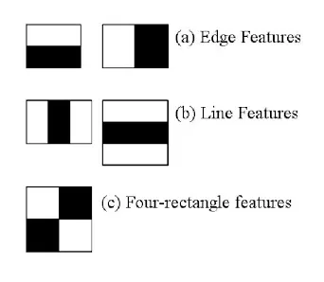
Fig 5.1. Types of Haar features.
Creating Integral Images
Instead of computing at every pixel, it instead creates sub-rectangles and creates array references for each of those sub-rectangles. These are then used to compute the Haar features.
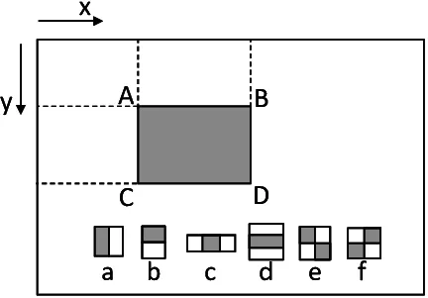
Fig 5.2. Illustration for how an integral image works.

Adaboost Training
Adaboost essentially chooses the best features and trains the classifiers to use them. It uses a combination of “weak classifiers” to create a “strong classifier” that the algorithm can use to detect objects.

Weak learners are created by moving a window over the input image, and computing Haar features for each subsection of the image. This difference is compared to a learned threshold that separates non-objects from objects. Because these are “weak classifiers,” a large number of Haar features is needed for accuracy to form a strong classifier.

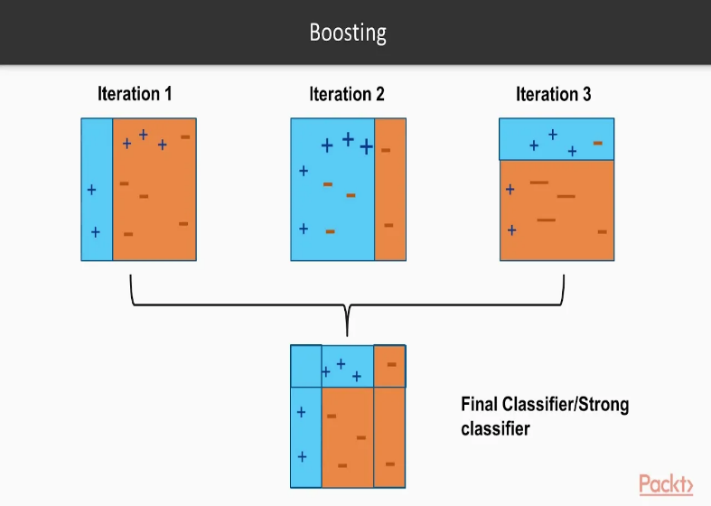
Fig 5.3. Representation of a boosting algorithm.
Implementing Cascading Classifiers
The cascade classifier is made up of a series of stages, where each stage is a collection of weak learners. Weak learners are trained using boosting, which allows for a highly accurate classifier from the mean prediction of all weak learners.

Based on this prediction, the classifier either decides to indicate an object was found (positive) or move on to the next region (negative). Stages are designed to reject negative samples as fast as possible, because a majority of the windows do not contain anything of interest.

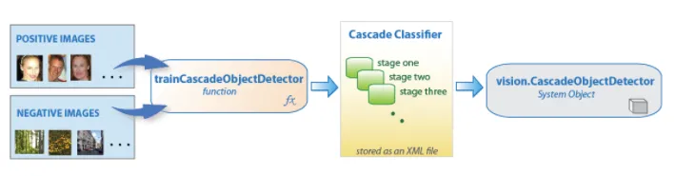
Fig 5.4. A flowchart of cascade classifiers.

6.SOFTWARE REQUIREMENT SPECIFICATION:

6.1.Requirement Specification:
Requirement Specification provides a high secure storage to the web server efficiently. Software requirements deal with software and hardware resources that need to be installed on a serve which provides optimal functioning for the application. These software and hardware requirements need to be installed before the packages are installed. These are the most common set of requirements defined by any operation system. These software and hardware requirements provide a compatible support to the operation system in developing an application.

6.1.1. Hardware Requirement:
The hardware requirement specifies each interface of the software elements and the hardware elements of the system. These hardware requirements include configuration characteristics.
- System: Intel core i5
- Hard Disk :256 GB
- Monitor : 15 VGA Color.
- Mouse: Any mouse
- RAM :4 GB.

6.1.2.Software Requirement:
The software requirements specify the use of all required software products like data management system. The required software product specifies the numbers and version. Each interface specifies the purpose of the interfacing software as related to this software product.
•Operating system : Windows 10
•Coding Language: Python 3.7

6.2.Functional Requirement:
Here are some functional requirements for the driver drowsiness detection project using Python and OpenCV:

Real-time Video Processing:
The system should continuously capture and process video frames in real-time from the camera feed.
The video feed should be displayed on the user interface.
Face and Eye Detection:
The system must accurately detect faces and eyes in the captured frames using Haar cascade classifiers.
Eye Aspect Ratio Calculation:
Calculate the Eye Aspect Ratio (EAR) using the detected eye landmarks to assess eye openness.
Drowsiness Detection Algorithm:
Implement an algorithm to monitor the EAR values over a defined time interval.
Set a threshold for EAR values below which the eyes are considered closed.
Drowsiness Alert Mechanism:
Trigger an alert mechanism (sound and visual) when the EAR falls below the threshold for a specified duration.
The user should be alerted in a way that effectively warns them of potential drowsiness.
User Interface (UI):
Design a simple and intuitive user interface to display the real-time video feed.
Display the alert status prominently when drowsiness is detected.
Provide options to adjust alert settings and thresholds.
Alert Sound Integration:
Play an audible alarm sound when drowsiness is detected.
The sound should be distinguishable and attention-grabbing.
Data Logging and Storage:
Log drowsiness events with timestamps and related data for later analysis.
Store the log data in a structured format, such as CSV or a database.
Configuration Settings:
Allow users to customize settings like time intervals for monitoring, EAR thresholds, and alert types.
Provide a user-friendly way to update these settings.
Testing and Calibration:
Provide mechanisms for users to calibrate the system to their comfort levels and preferences.
Offer a testing mode to simulate drowsiness conditions and assess system responsiveness.
Crime Prediction Modules (If applicable, as mentioned in the project description):
Implement machine learning models for crime prediction using historical data and covariates.
Train and evaluate different models, including LSTM, KNN, random forest, SVM, naive Bayes, and CNN.
Integrate covariate data to enhance prediction accuracy.
Documentation:
Prepare detailed documentation on how to set up and use the system.
Include explanations of the algorithms, modules, and parameters used.
Error Handling and Recovery:
Implement error handling mechanisms to handle potential exceptions during runtime.
Ensure the system can recover gracefully from errors without crashing.
Performance Optimization:
Optimize the system's performance to ensure real-time processing and minimal resource consumption.
Monitor memory usage and processing speed to avoid slowdowns.
Compatibility and Portability:
Ensure the project is compatible with different camera devices and environments.
Consider platform-specific requirements for Windows, macOS, and Linux systems.
Remember that these functional requirements will serve as a guide for developing and testing your project. Regularly iterate and refine the system based on user feedback and testing results to improve its effectiveness and user experience.

6.3.Nonfunctional Requirement:

All the other requirements which do not form a part of the above specification are categorized as Non-Functional needs. A system perhaps needed to gift the user with a show of the quantity of records during info. If the quantity must be updated in real time, the system architects should make sure that the system is capable of change the displayed record count at intervals associate tolerably short interval of the quantity of records dynamic. Comfortable network information measure may additionally be a non-functional requirement of a system.
The following are the features:
➢Accessibility
➢Availability
➢Backup
➢Certification
➢Compliance
➢Configuration Management
➢Documentation
➢Disaster Recovery
➢Efficiency(resource consumption for given load)
➢Interoperability

6.4 Performance Requirements
Performance is measured in terms of the output provided by the application. Requirement specification plays an important part in the analysis of a system. Only when the requirement specifications are properly given, it is possible to design a system, which will fit into required environment. It rests largely with the users of the existing system to give the requirement specifications because they are the people who finally use the system. This is because the requirements have to be known during the initial stages so that the system can be designed according to those requirements. It is very difficult to change the system once it has been designed and on the other hand designing a system, which does not cater to the requirements of the user, is of no use.
The requirement specification for any system can be broadly stated as given below:
•The system should be able to interface with the existing system
•The system should be accurate
•The system should be better than the existing system
The existing system is completely dependent on the user to perform all the duties.

6.5 Feasibility Study:

The feasibility of the project is analyzed in this phase and business proposal is put forth with a very general plan for the project and some cost estimates. During system analysis the feasibility study of the proposed system is to be carried out. This is to ensure that the proposed system is not a burden to the company. For feasibility analysis, some understanding of the major requirements for the system is essential.
Three key considerations involved in the feasibility analysis are
Economical Feasibility
Technical Feasibility
Operational Feasibility

6.5.1 Technical Feasibility

The technical issue usually raised during the feasibility stage of the investigation includes the following:
•Does the necessary technology exist to do what is suggested?
•Do the proposed equipments have the technical capacity to hold the data required to use the new system?
•Will the proposed system provide adequate response to inquiries, regardless of the number or location of users?
•Can the system be upgraded if developed?
Are there technical guarantees of accuracy, reliability, ease of access and data security?

6.5.2 Operational Feasibility

User-friendly
Customer will use the forms for their various transactions i.e. for adding new routes, viewing the routes details. Also the Customer wants the reports to view the various transactions based on the constraints. These forms and reports are generated as user-friendly to the Client.
Reliability
The package wills pick-up current transactions on line. Regarding the old transactions, User will enter them in to the system.
Security
The web server and database server should be protected from hacking, virus etc

Portability
The application will be developed using standard open source software (Except Oracle) like Java, tomcat web server, Internet Explorer Browser etc these software will work both on Windows and Linux o/s. Hence portability problems will not arise.
Availability
This software will be available always.
Maintainability
The system uses the 2-tier architecture. The 1st tier is the GUI, which is said to be front-end and the 2nd tier is the database, which uses My-Sql, which is the back-end.
The front-end can be run on different systems (clients). The database will be running at the server. Users access these forms by using the user-ids and the passwords.

6.5.3 Economic Feasibility
The computerized system takes care of the present existing system’s data flow and procedures completely and should generate all the reports of the manual system besides a host of other management reports.
It should be built as a web based application with separate web server and database server. This is required as the activities are spread throughout the organization customer wants a centralized database. Further some of the linked transactions take place in different locations.

7.METHODOLOGY
7.1.SDLC (Software Development Life Cycle)
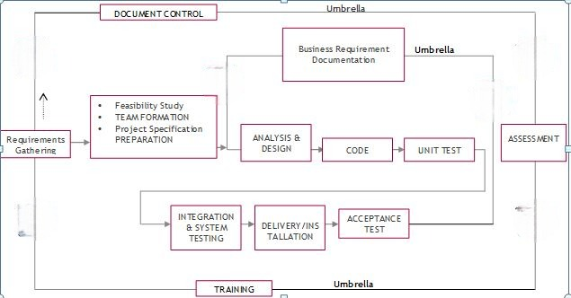

Fig no. 7.1 SDLC Cycle

SDLC is nothing but Software Development Life Cycle. It is a standard which is used by software industry to develop good software.

7.1.1.Requirements Gathering Stage
The requirements gathering process takes as its input the goals identified in the high-level requirements section of the project plan. Each goal will be refined into a set of one or more requirements. These requirements define the major functions of the intended application, define operational data areas and reference data areas, and define the initial data entities. Major functions include critical processes to be managed, as well as mission critical inputs, outputs and reports. A user class hierarchy is developed and associated with these major functions, data areas, and data entities. Each of these definitions is termed a Requirement. Requirements are identified by unique requirement identifiers and, at minimum, contain a requirement title and textual description.

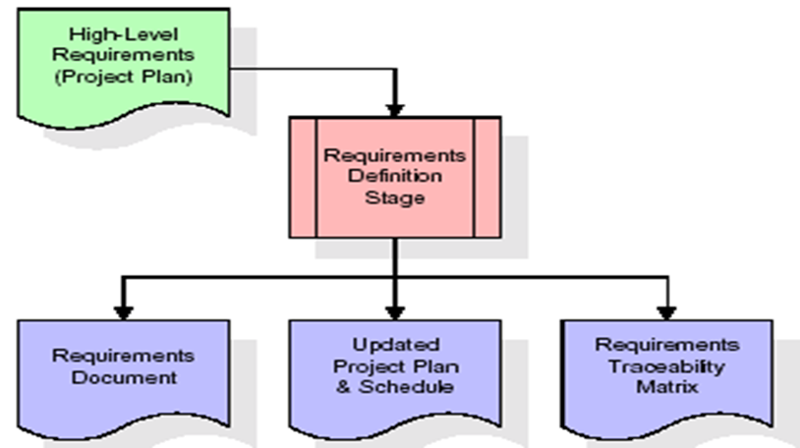

Fig 7.2 Requirements Gathering stage

These requirements are fully described in the primary deliverables for this stage: the Requirements Document and the Requirements Traceability Matrix (RTM). The requirements document contains complete descriptions of each requirement, including diagrams and references to external documents as necessary. Note that detailed listings of database tables and fields are not included in the requirements document.
The title of each requirement is also placed into the first version of the RTM, along with the title of each goal from the project plan. The purpose of the RTM is to show that the product components developed during each stage of the software development lifecycle are formally connected to the components developed in prior stages.
In the requirements stage, the RTM consists of a list of high-level requirements, or goals, by title, with a listing of associated requirements for each goal, listed by requirement title. In this hierarchical listing, the RTM shows that each requirement developed during this stage is formally linked to a specific product goal. In this format, each requirement can be traced to a specific product goal, hence the term requirements traceability.
The outputs of the requirements definition stage include the requirements document, the RTM, and an updated project plan.
Feasibility study is all about identification of problems in a project, number of staff required to handle a project is represented as Team Formation, in this case only modules are individual tasks will be assigned to employees who are working for that project.
Project Specifications are all about representing of various possible inputs submitting to the server and corresponding outputs along with reports maintained by administrator.

7.1.2.Analysis Stage
The planning stage establishes a bird's eye view of the intended software product, and uses this to establish the basic project structure, evaluate feasibility and risks associated with the project, and describe appropriate management and technical approaches.

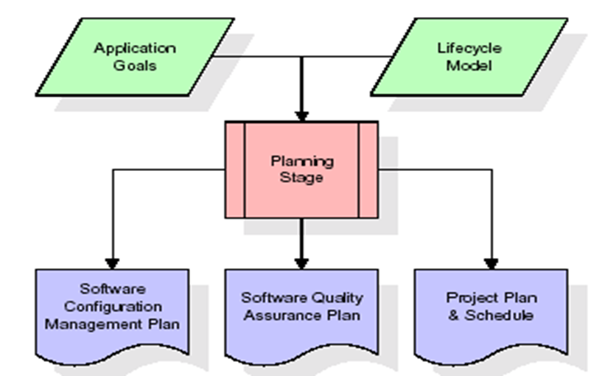

Fig 7.3 Analysis stage

The most critical section of the project plan is a listing of high-level product requirements, also referred to as goals. All of the software product requirements to be developed during the requirements definition stage flow from one or more of these goals. The minimum information for each goal consists of a title and textual description, although additional information and references to external documents may be included. The outputs of the project planning stage are the configuration management plan, the quality assurance plan, and the project plan and schedule, with a detailed listing of scheduled activities for the upcoming Requirements stage, and high level estimates of effort for the out stages.

7.1.3.Designing Stage
The design stage takes as its initial input the requirements identified in the approved requirements document. For each requirement, a set of one or more design elements will be produced as a result of interviews, workshops, and/or prototype efforts. Design elements describe the desired software features in detail, and generally include functional hierarchy diagrams, screen layout diagrams, tables of business rules, business process diagrams, pseudo code, and a complete entity-relationship diagram with a full data dictionary. These design elements are intended to describe the software in sufficient detail that skilled programmers may develop the software with minimal additional input.

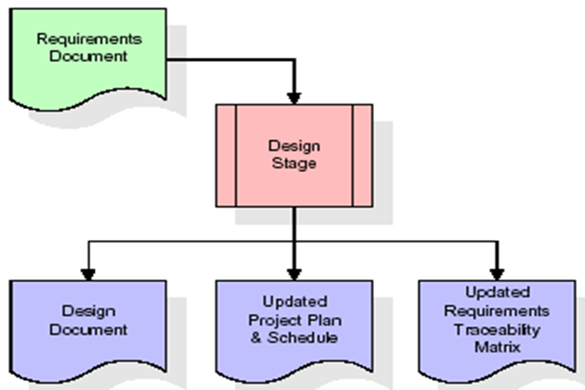
Fig 7.4 Designing stage

When the design document is finalized and accepted, the RTM is updated to show that each design element is formally associated with a specific requirement. The outputs of the design stage are the design document, an updated RTM, and an updated project plan.

7.1.4.Development (Coding) Stage

The development stage takes as its primary input the design elements described in the approved design document. For each design element, a set of one or more software artifacts will be produced. Software artifacts include but are not limited to menus, dialogs, data management forms, data reporting formats, and specialized procedures and functions. Appropriate test cases will be developed for each set of functionally related software artifacts, and an online help system will be developed to guide users in their interactions with the software.

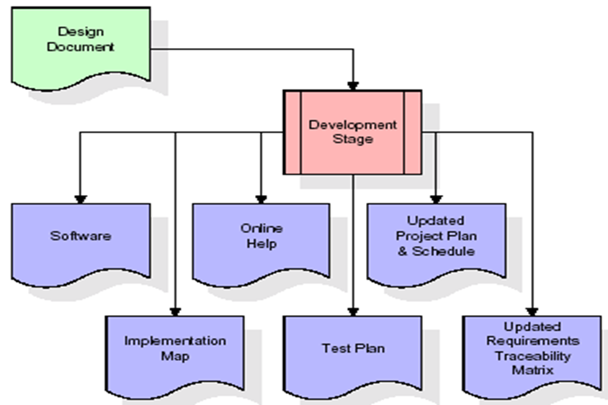

Fig 7.5 Coding stage

7.1.5.Integration& Test Stage
During the integration and test stage, the software artifacts, online help, and test data are migrated

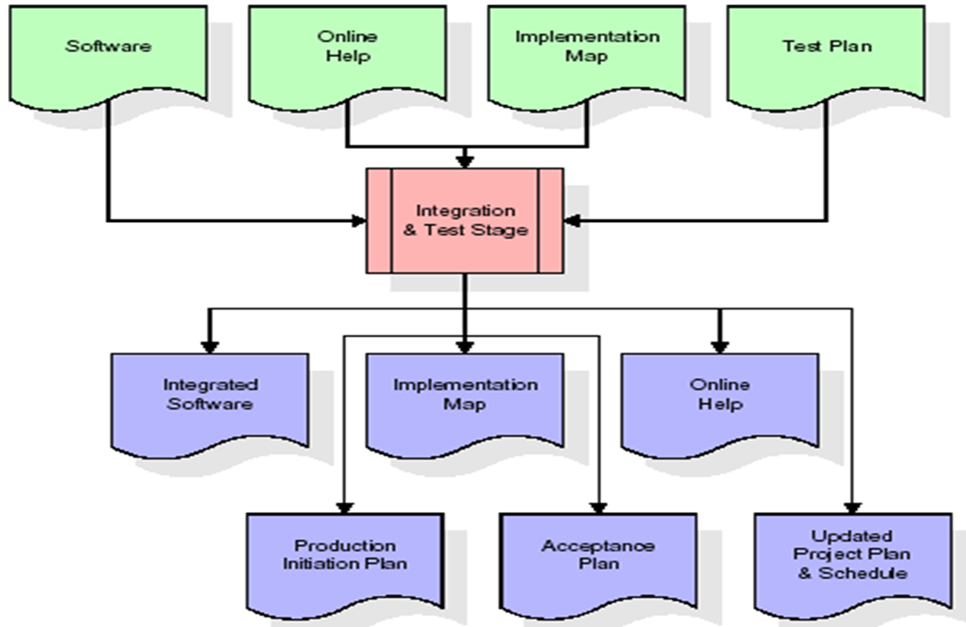
Fig 7.6.Integration and Test stage

from the development environment to a separate test environment. At this point, all test cases are run to verify the correctness and completeness of the software. Successful execution of the test suite confirms a robust and complete migration capability. During this stage, reference data is finalized for production use and production users are identified and linked to their appropriate roles. The final reference data (or links to reference data source files) and production user list are compiled into the Production Initiation Plan.

7.1.6.Installation& Acceptance Test
During the installation and acceptance stage, the software artifacts, online help, and initial production data are loaded onto the production server. At this point, all test cases are run to verify the correctness and completeness of the software. Successful execution of the test suite is a prerequisite to acceptance of the software by the customer.
After customer personnel have verified that the initial production data load is correct and the test suite has been executed with satisfactory results, the customer formally accepts the delivery of the software.
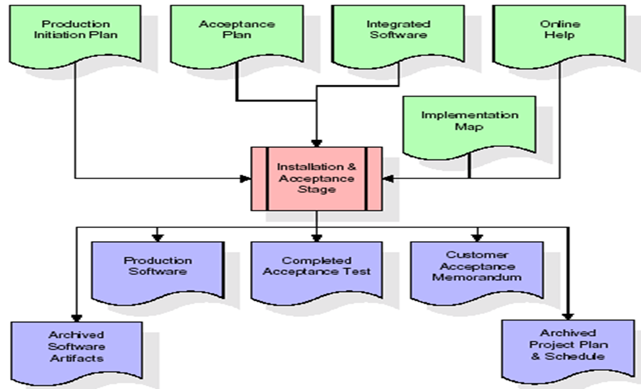

Fig 7.7.Installation

7.1.7Maintenance
Outer rectangle represents maintenance of a project, Maintenance team will start with requirement study, understanding of documentation later employees will be assigned work and they will undergo training on that particular assigned category.

8.SYSTEM DESIGN

8.1 System Architecture

The purpose of the design phase is to arrange an answer of the matter such as by the necessity document. This part is that the opening moves in moving the matter domain to the answer domain. The design phase satisfies the requirements of the system. The design of a system is probably the foremost crucial issue warm heartedness the standard of the software package. It’s a serious impact on the later part, notably testing and maintenance.
The output of this part is that the style of the document. This document is analogous to a blueprint of answer and is employed later throughout implementation, testing and maintenance. The design activity is commonly divided into 2 separate phases System Design and Detailed Design.
System Design conjointly referred to as top-ranking style aims to spot the modules that ought to be within the system, the specifications of those modules, and the way them move with one another to supply the specified results.
At the top of the system style all the main knowledge structures, file formats, output formats, and also the major modules within the system and their specifications square measure set. System design is that the method or art of process the design, components, modules, interfaces, and knowledge for a system to satisfy such as needs. Users will read it because the application of systems theory to development.
Detailed Design, the inner logic of every of the modules laid out in system design is determined. Throughout this part, the small print of the info of a module square measure sometimes laid out in a high-level style description language that is freelance of the target language within which the software package can eventually be enforced.
In system design the main target is on distinguishing the modules, whereas throughout careful style the main target is on planning the logic for every of the modules.

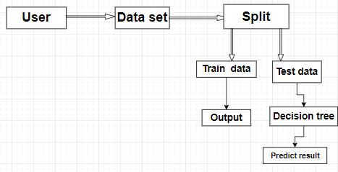

Fig 8.1: Architecture diagram

8.2 UML DIAGRAMS

The Unified Modeling Language allows the software engineer to express an analysis model using the modeling notation that is governed by a set of syntactic semantic and pragmatic rules.
A UML system is represented using five different views that describe the system from distinctly different perspective. Each view is defined by a set of diagram, which is as follows.
User Model View
This view represents the system from the user’s perspective. The analysis representation describes a usage scenario from the end-users perspective.
Structural Model view
In this model the data and functionality are arrived from inside the system. This model view models the static structures.
Behavioral Model View
It represents the dynamic of behavioral as parts of the system, depicting the interactions of collection between various structural elements described in the user model and structural model view.
Implementation Model View
In this the structural and behavioral as parts of the system are represented as they are to be built.
The Unified Modeling Language is a standard language for specifying, Visualization, Constructing and documenting the artifacts of software system, as well as for business modeling and other non-software systems.
The UML is a very important part of developing object-oriented software and the software development process. The UML uses mostly graphical notations to express the design of software projects.

8.2.1Use Case Diagram
A use case diagram in the Unified Modeling Language (UML) is a type of behavioral diagram defined by and created from a Use-case analysis. Its purpose is to present a graphical overview of the functionality provided by a system in terms of actors, their goals (represented as use cases), and any dependencies between those use cases. The main purpose of a use case diagram is show what system functions are performed for which actor. Roles of the actors in the system can be depicted.
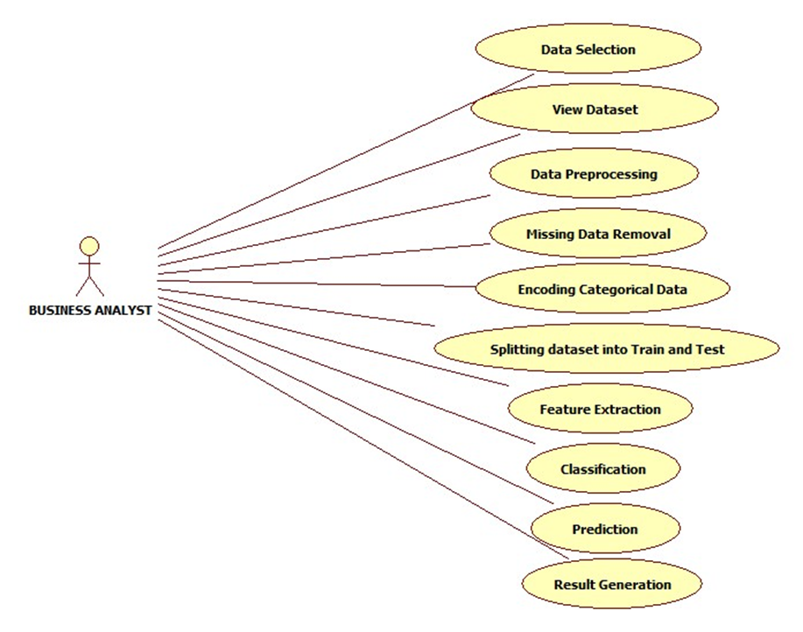
Fig 8.2 Use Case Diagram

9.SYSTEM TESTING
Software testing is a crucial phase in software development that aims to identify and rectify defects, errors, and vulnerabilities in the application. It ensures that the software meets its functional requirements, works as expected, and provides a satisfactory user experience. In the context of your driver drowsiness detection project, here's how you can approach software testing:
Unit Testing:
Test individual components and functions of your project in isolation.
Verify that each module behaves as intended and produces correct outputs for various inputs.
Use testing frameworks like unittest or pytest in Python to automate unit tests.
Integration Testing:
Test the interaction between different modules or components of your project.
Ensure that the integration of various parts doesn't introduce new errors or unexpected behavior.
Verify that data flows smoothly between components.
Functional Testing:
Test the complete functionality of your drowsiness detection system.
Check if the system accurately detects drowsiness, triggers alerts, and provides appropriate responses.
Validate the correctness of the drowsiness detection algorithm.
User Interface (UI) Testing:
Evaluate the user interface for usability, responsiveness, and visual appeal.
Ensure that user interactions, such as adjusting settings or viewing alerts, work as expected.
Test on different devices and screen sizes to ensure responsiveness.
Performance Testing:
Assess the performance of your application under various conditions, including high load and real-time processing.
Monitor CPU and memory usage to identify any resource bottlenecks.
Measure the responsiveness of the system during drowsiness detection.
Stress Testing:
Push the application to its limits by simulating a large number of users or excessive data input.
Identify how the system behaves under stress and determine its breaking point.
Security Testing (Optional, depending on project scope):
Evaluate the application's vulnerability to potential security threats and attacks.
Verify that user data is handled securely and that there are no potential data breaches.
Usability Testing:
Involve real users in testing to gather feedback on the system's user-friendliness.
Ensure that the interface is intuitive, easy to navigate, and meets user expectations.
Regression Testing:
Perform testing after making changes to the codebase to ensure that new modifications do not introduce new defects.
Re-run previous tests to verify that existing functionalities are not negatively impacted.
User Acceptance Testing (UAT):
Involve end-users in testing to validate that the application meets their needs and requirements.
Address user feedback and make necessary adjustments.
Documentation and Reporting:
Document test plans, test cases, and the results of each test.
Report identified defects, issues, and potential improvements.
Keep track of resolved and pending issues.
Remember that testing is an iterative process, and you may need to repeat certain tests as you make changes or enhancements to your project. Proper testing helps ensure the reliability, functionality, and quality of your driver drowsiness detection system.

9.1.SYSTEM TESTING

Testing has become an integral part of any system or project especially in the field of information technology. The importance of testing is a method of justifying, if one is ready to move further, be it to be check if one is capable to with stand the rigors of a particular situation cannot be underplayed and that is why testing before development is so critical. When the software is developed before it is given to user to user the software must be tested whether it is solving the purpose for which it is developed. This testing involves various types through which one can ensure the software is reliable. The program was tested logically and pattern of execution of the program for a set of data are repeated. Thus the code was exhaustively checked for all possible correct data and the outcomes were also checked.

9.2 MODULE TESTING

To locate errors, each module is tested individually. This enables us to detect error and correct it without affecting any other modules. Whenever the program is not satisfying the required function, it must be corrected to get the required result. Thus all the modules are individually tested from bottom up starting with the smallest and lowest modules and proceeding to the next level. Each module in the system is tested separately. For example the job classification module is tested separately. This module is tested with different job and its approximate execution time and the result of the test is compared with the results that are prepared manually. Each module in the system is tested separately. In this system the resource classification and job scheduling modules are tested separately and their corresponding results are obtained which reduces the process waiting time.

9.3 INTEGRATION TESTING

After the module testing, the integration testing is applied. When linking the modules there may be chance for errors to occur, these errors are corrected by using this testing. In this system all modules are connected and tested. The testing results are very correct. Thus the mapping of jobs with resources is done correctly by the system.

9.4 ACCEPTANCE TESTING

When that user fined no major problems with its accuracy, the system passers through a final acceptance test. This test confirms that the system needs the original goals, objectives and requirements established during analysis without actual execution which elimination wastage of time and money acceptance tests on the shoulders of users and management, it is finally acceptable and ready for the operation.

10.OUTPUT SCREENS

11.FUTURE WORK

The future of driver drowsiness detection projects holds great potential for further advancements and applications. Here are some potential directions for future work in this area:

Integration with Autonomous Vehicles: As autonomous vehicle technology advances, integrating driver drowsiness detection systems into these vehicles becomes crucial for ensuring passenger safety. Future work could focus on developing robust drowsiness detection algorithms that seamlessly integrate with autonomous driving systems.
Real-time Monitoring and Feedback: Enhancing real-time monitoring capabilities can provide immediate feedback to drivers, alerting them when they show signs of drowsiness. This could involve the use of wearable devices or in-vehicle sensors that continuously monitor driver behavior and physiological signals.
Personalized Detection Algorithms: Developing personalized drowsiness detection algorithms that adapt to individual differences in behavior, physiology, and response to fatigue could improve the accuracy and effectiveness of these systems. Machine learning techniques could be employed to tailor detection algorithms to specific drivers based on their unique characteristics and driving patterns.
Multi-modal Sensor Fusion: Integrating data from multiple sensors, such as cameras, steering wheel sensors, and physiological monitors, can improve the accuracy and reliability of drowsiness detection systems. Future work could explore advanced sensor fusion techniques to combine information from different modalities and enhance the overall performance of these systems.
Behavioral Intervention Strategies: Beyond simply detecting drowsiness, future research could focus on developing proactive intervention strategies to prevent fatigue-related accidents. This could involve implementing adaptive in-vehicle systems that provide alerts, adjust driving conditions, or suggest rest breaks based on the detected level of driver fatigue.
Long-term Monitoring and Analysis: Continuous monitoring of driver behavior over extended periods could provide valuable insights into the factors contributing to drowsiness and fatigue. Future work could involve longitudinal studies to analyze trends, patterns, and risk factors associated with driver drowsiness, informing the development of more effective prevention and intervention strategies.
Validation and Standardization: Further validation and standardization of drowsiness detection technologies are essential to ensure their reliability and widespread adoption. Future research could focus on conducting large-scale studies to evaluate the performance of these systems across different driving conditions, populations, and environments.
Regulatory Compliance and Adoption: Collaborating with regulatory agencies and industry stakeholders to establish guidelines, standards, and regulations for drowsiness detection technologies can facilitate their integration into vehicles and promote widespread adoption. Future work could involve engaging with policymakers and industry partners to address regulatory hurdles and promote the deployment of these life-saving technologies.
By focusing on these areas, future work in driver drowsiness detection can contribute to improving road safety and reducing the incidence of fatigue-related accidents.

12.CONCLUSION
In conclusion, the development of a driver drowsiness detection project using Python and the OpenCV library represents a significant step toward enhancing road safety and preventing accidents caused by driver fatigue. By leveraging computer vision techniques, the project effectively monitors a driver's face and eye activity in real-time, providing timely alerts when signs of drowsiness are detected. This proactive approach has the potential to save lives and reduce the risks associated with drowsy driving.

The integration of Haar cascade classifiers for face and eye detection, along with the calculation of the Eye Aspect Ratio (EAR), enables accurate assessment of eye openness. The implemented drowsiness detection algorithm, combined with configurable settings and alert mechanisms, ensures that the system can be tailored to individual preferences and sensitivity levels. The user interface provides an intuitive platform for drivers to monitor their own alertness and take necessary actions to stay attentive on the road.

Additionally, if applicable, the project's extension into crime prediction analysis showcases the versatility of machine learning algorithms in addressing broader societal challenges. The utilization of different models, such as LSTM, KNN, random forest, SVM, naive Bayes, and CNN, demonstrates the effectiveness of machine learning in predicting crime patterns based on historical data and relevant covariates. The integration of built environment data further enhances prediction accuracy, highlighting the importance of considering external factors in crime prevention strategies.

Throughout the development process, thorough software testing played a pivotal role in ensuring the reliability, accuracy, and user-friendliness of the application. By rigorously testing individual components, integration, functionality, user interface, performance, and potential vulnerabilities, the project's quality was assured, and any defects were addressed. User feedback, real-world testing, and continuous iterations contribute to the refinement of the project's capabilities and overall success.

In summary, the driver drowsiness detection project, coupled with the crime prediction analysis, showcases the potential of technology, machine learning, and data integration in tackling pressing safety and societal issues. These efforts exemplify the positive impact that innovative applications and interdisciplinary approaches can have on enhancing safety measures and preventative strategies in the real world. Through ongoing improvements and advancements, these projects have the potential to make our roads safer and contribute to safer communities...

Future Enhancements:

It is not possible to develop a system that makes all the requirements of the user. User requirements keep changing as the system is being used. Some of the future enhancements that can be done to this system are:

•As the technology emerges, it is possible to upgrade the system and can be adaptable to desired environment.
•Based on the future security issues, security can be improved using emerging technologies like single sign-on.

In conclusion, driver drowsiness detection projects represent a critical area of research and development aimed at enhancing road safety and preventing fatigue-related accidents. Through the integration of advanced sensing technologies, machine learning algorithms, and real-time monitoring capabilities, these projects have the potential to detect signs of driver fatigue and intervene proactively to mitigate the risks associated with drowsy driving.

Key advancements in driver drowsiness detection include the development of multi-modal sensor fusion techniques, personalized detection algorithms, and integration with autonomous vehicle systems. These innovations enable more accurate and reliable detection of drowsiness, tailored to individual drivers' characteristics and driving patterns.

Furthermore, future work in this field can focus on refining intervention strategies, such as real-time alerts, adaptive driving conditions, and personalized recommendations for rest breaks. Longitudinal studies and collaboration with regulatory agencies and industry stakeholders are essential for validating and standardizing drowsiness detection technologies, as well as promoting their widespread adoption and regulatory compliance.

Ultimately, driver drowsiness detection projects have the potential to save lives by reducing the incidence of fatigue-related accidents and promoting safer driving behaviors. Continued research, innovation, and collaboration in this area will contribute to achieving the goal of safer roads for all.

In summary, driver drowsiness detection projects represent a significant step forward in addressing one of the leading causes of road accidents worldwide. By leveraging advancements in technology, such as machine learning, sensor fusion, and real-time monitoring, these projects offer promising solutions to mitigate the risks associated with drowsy driving.

Through the development of accurate and reliable detection algorithms, coupled with proactive intervention strategies, such as real-time alerts and adaptive driving assistance, these projects aim to enhance road safety and prevent potential tragedies on the highways.

Moreover, the integration of drowsiness detection systems into autonomous vehicles holds immense potential for ensuring passenger safety in the era of self-driving cars. By combining these technologies, we can create a future where the risk of drowsy driving accidents is significantly reduced, if not altogether eliminated.

However, to realize this vision, further research, validation, and collaboration are necessary. Long-term studies, standardization efforts, and regulatory compliance are crucial steps to ensure the effectiveness and widespread adoption of drowsiness detection technologies.

In conclusion, driver drowsiness detection projects represent a vital endeavor in the pursuit of safer roads and transportation systems. Through continued innovation and collaboration, we can strive towards a future where drowsy driving accidents are a thing of the past, and every journey is a safer one.

14.REFERENCES

[1] Agarwal, Apoorv, Fadi Biadsy, and Kathleen R. Mckeown. "Contextual phrase-level polarity analysis using lexical affect scoring and syntactic n-grams." Proceedings of the 12th Conference of the European Chapter of the Association for Computational Linguistics. Association for Computational Linguistics, 2009.

[2] Barbosa, Luciano, and Junlan Feng. "Robust sentiment detection on twitter from biased and noisy data." Proceedings of the 23rd international conference on computational linguistics: posters. Association for Computational Linguistics, 2010.

[3] Bermingham, Adam, and Alan F. Smeaton. "Classifying sentiment in microblogs: is brevity an advantage?." Proceedings of the 19th ACM international conference on Information and knowledge management. ACM, 2010.

[4] Gamon, Michael. "Sentiment classification on customer feedback data: noisy data, large feature vectors, and the role of linguistic analysis." Proceedings of the 20th international conference on Computational Linguistics. Association for Computational Linguistics, 2004.

[5] Kim, Soo-Min, and Eduard Hovy. "Determining the sentiment of opinions." Proceedings of the 20th international conference on Computational Linguistics. Association for Computational Linguistics, 2004.

[6] Klein, Dan, and Christopher D. Manning. "Accurate unlexicalized parsing." Proceedings of the 41st Annual Meeting on Association for Computational Linguistics-Volume 1. Association for Computational Linguistics, 2003.

[7] Charniak, Eugene, and Mark Johnson. "Coarse-to-fine n-best parsing and MaxEnt discriminative reranking." Proceedings of the 43rd annual meeting on association for computational linguistics. Association for Computational Linguistics, 2005.

[8] Gupta, B., Negi, M., Vishwakarma, K., Rawat, G., &Badhani, P. (2017). Study of Twitter sentiment analysis using machine learning algorithms on Python. International Journal of Computer Applications, 165(9), 0975-8887.

[9] Sahayak, V., Shete, V., & Pathan, A. (2015). Sentiment analysis on twitter data. International Journal of Innovative Research in Advanced Engineering (IJIRAE), 2(1), 178-183.

[10] Mamgain, N., Mehta, E., Mittal, A., & Bhatt, G. (2016, March). Sentiment analysis of top colleges in India using Twitter data. In Computational Techniques in Information and Communication Technologies (ICCTICT), 2016 International Conference on (pp. 525-530). IEEE

